Facebook Fortunes Webinar Agenda
Webinar 21
Facebook Lead Ads
- What is a Facebook Lead Ad
- What are the advantages and disadvantages
- Where to find a FB Lead Ad
- How to run a Facebook Lead Ad Campaign
- Hooking it up to your Autoresponder

1: What is a Facebook Lead AD:
Facebook rolled out Lead ads to help overcome people’s apprehension to filling out forms.
“You know what no one’s ever said? “I love filling out forms.”
Which is a shame, because forms are pretty useful things. That’s why we’re testing Lead ads, a new, simpler way for people to fill out forms on their mobile devices….
…Lead ads make the mobile signup process easier by automatically populating contact information that people have given Facebook, like email addresses.
Simply put… Lead ads allow advertisers to collect information from prospects directly from mobile ads.
Instead of sending traffic to a landing page where people manually fill out a form and press submit, they click on the ad, their information (name & email) is pre-populated, and they hit submit.
All within the Facebook platform.
Let’s take a look at an example…
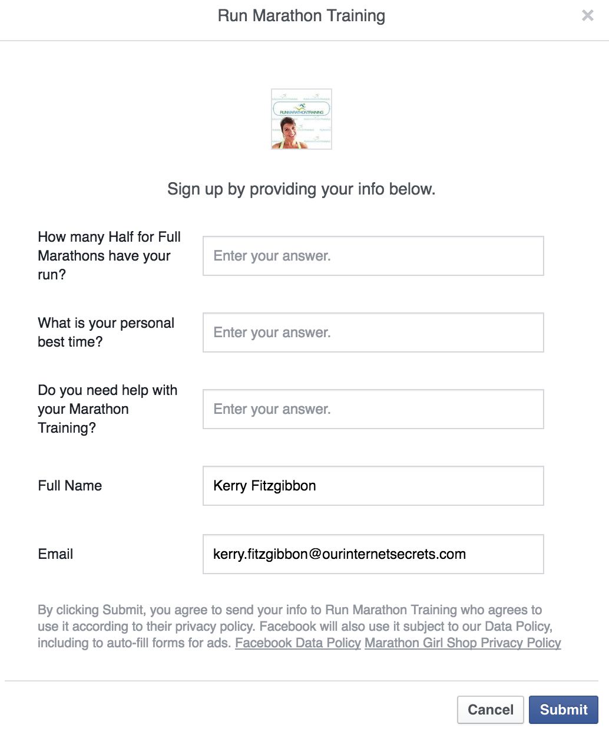


2: What are the advantages and disadvantages

Advantages:

Nice and easy to set up in Ads Manager or Power Editor

Easy for the end user to opt-in to your funnel

End user doesn't have to leave Facebook

Collect lead ad audience

Disadvantages

Less qualified leads

Doesn’t collect the website audience

Can’t edit form if you make a mistake (have to create new form)

3: Where to find the Facebook Lead Ad

Go to Ads Manager or Power Editor click on create an ad then choose Lead Generation as your objective.

Demo

4: How to create a Lead Ad

Demo

5: Hooking it up to your auto-responder

Demo

