Facebook Fortunes Webinar Agenda
Webinar 3
List Building (part 2) – Opt in page
- Tips for creating a good opt in page
- Examples of opt in pages
- How to build your opt in pages
- Tips for creating a good opt in page (aka landing page, squeeze page, lead page)
- Should convert at 20-30%
- Uncluttered (one purpose per page)
- Short
- Graphics and copy match your Facebook business page banner and FB ad
- Ask for minimal details (eg name and email)
- Focus on benefits in the headline and “what you’ll get” bullets
- Use 3-5 bullets that create curiosity
- Make it easy and obvious how to opt in
- Put the opt in box above the fold (and again at the end if necessary)
- Add testimonials
- Add an image of the free gift (note – putting a hand behind a disc massively increases opt ins!, eg http://ourinternetsecrets.com/free/)
- Put the Facebook pixel on the opt in page to create a website custom audience
- Test adding video or audio
- Put the call to action on the submit button, eg Get My Free List Building Guide
- Have a matching thank you page
- Hook up to your autoresponder, eg aweber (have the first email prepared, and switch off double opt in)
- Test and measure until the opt in rate is 20-30%
- Examples of Opt in pages

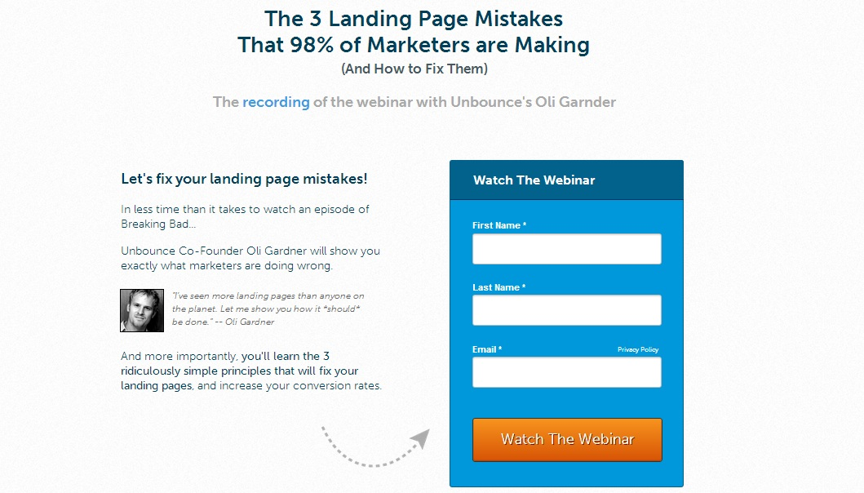

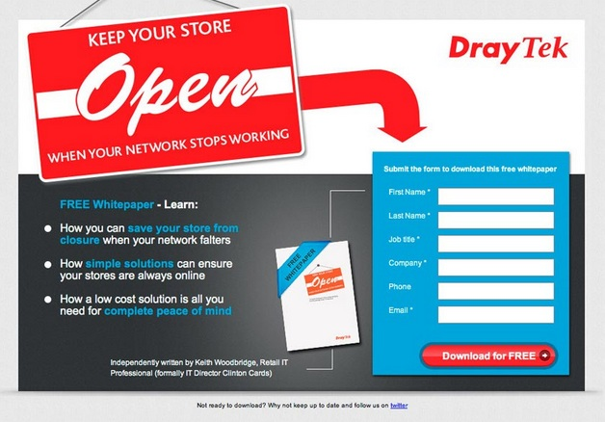

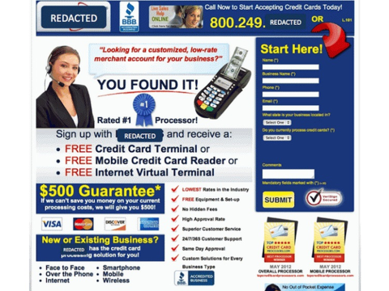

- How to build your opt in pages
- If you are in the Platinum level of the Facebook Fortunes program we will build one opt in page for each of your 5 income streams
- Outsource to www.Fiverr.com
- Build your own using Clickfunnels – 14 day free trial: http://bit.ly/1UXtEEP

